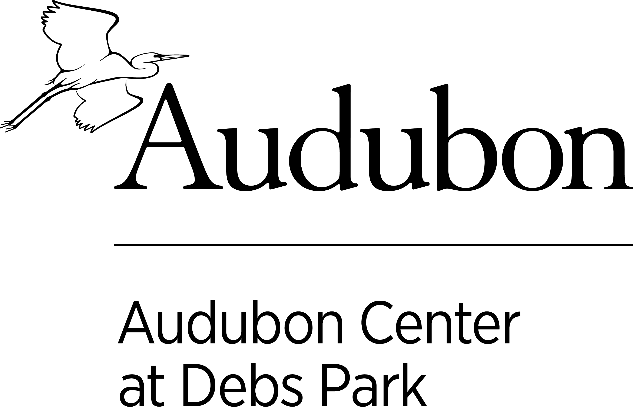
Audubon Youth Leaders Application
Audubon Center at Debs Park is looking for 10th and 11th graders with a wide range of interests to join our Audubon Youth Leaders (AYL) program. We seek students who are open to new experiences, want to be part of a diverse collaborative team, and want to make a difference. No prior experience is required. Audubon Youth Leaders must be willing to commit to the outlined times and days and work to the best of their abilities for the duration of the program. Audubon Center staff will provide ongoing support throughout the program.
Audubon Center en Debs Park está buscando estudiantes del 10º y 11º grado interesados en unirse a nuestro programa de Líderes Juveniles Audubon (Audubon Youth Leaders). Buscamos estudiantes que estén buscando nuevas experiencias, que quieran ser parte de un equipo colaborativo y diverso. No se requiere experiencia previa. Los líderes juveniles de Audubon deben estar dispuestos a comprometerse con los horarios y días descritos y trabajar lo mejor que puedan durante la duración del programa. El personal del Centro Audubon brindará apoyo continuo durante todo el programa.

Program Dates/ Días de Programa: May 14th, 2022 to June 18th, 2022
Program Time/ Tiempo de Programa: Saturdays 11:00 a.m. to 3:00p.m. *there will be one week you will work afterschool from home during the week. Habrá una semana en la que trabajarás desde casa durante la semana, después de escuela.
There is a $250 Educational Award for completing the program that will be distributed at the end of the program.
Hay un Premio Educativo de $ 250 por completar el programa que se distribuirá al final del programa.

Contact: Evelyn, Public Programs Manager (323)-221-2255 ext. 115 or evelyn.serrano@audubon.org
Address: 4700 North Griffin Ave, Los Angeles, Ca 90031
Part I: Applicant Information- to be filled out by program applicant (Please print neatly in ink or type)
Name ___________________________________________________________________________________________
First Middle Last
Street address__________________________________________________________
City_________________________ State_______ Zip Code____________
Home Phone __________________ Cell Phone _____________________
Birthdate: _____/_____/_____ Email: __________________________________
Month Day Year
Have you participated in Audubon Center at Debs Park programming before: YES NO
School/Program attending ______________________________________________ Age (in Spring ‘22) ________
Current GPA ________
How did you hear about the Audubon Youth Leaders program? ______________________
I acknowledge that the above statements are true and complete to the best of my knowledge.
____________________________ ________________
Applicant Signature Date
Thank you for your interest in applying to be an Audubon Youth Leader!

Part II: Commitment/Availability

AYL Requirements/ Requisitos:
- Staying enrolled in public high school or alternative program. /Permanecer inscrito en una escuela secundaria pública o en un programa alternativo
- Commitment May 14th 2022- June 18th, 2022, Saturdays 11:00am-3:00pm AND May 16th-20th after school. / Compromiso 14 de mayo de 2022 - 18 de junio de 2022, sábados 11:00am-3:00pm Y 16-20 de mayo después de escuela.
- Fully engaging and participating in trainings, outdoor work, planning, implementing, and presenting team-led project, working in collaboration with peer Youth Leader team and Audubon Staff. / Participar completamente en actividades, trabajo al aire libre, planificación, implementación y presentación de proyectos, trabajando en colaboración con el equipo de Líderes Juveniles y el personal de Audubon.
- Maintaining a positive attitude and respect towards Youth Leader team members and Audubon staff. / Mantener una actitud positiva y respeto hacia los miembros del equipo de Youth Leader y el personal de Audubon.

Education awards are distributed one time throughout the AYL program. I understand that I must meet the above requirements in order to receive my full education award. /Los premios de educación se distribuyen una vez a lo largo del programa AYL. Entiendo que debo cumplir con los requisitos anteriores para recibir mi premio de educación completo.

___________________________________________ ______________________
Applicant Signature/ Firma del solicitante Date/Fecha

I fully understand the commitment involved in the AYL program as outlined in the application. If I am selected, I am willing to participate fully and to the best of my ability. I also understand that I will receive a calendar of program dates./ Entiendo completamente el compromiso involucrado en el programa AYL como se describe en la solicitud. Si soy seleccionado, estoy dispuesto a participar lo mejor que pueda. También entiendo que recibiré un calendario de fechas del programa.

___________________________________________ ______________________
Applicant Signature/ Firma del solicitante Date/ Fecha

Parent/Guardian Approval Form

I understand the expectations of the AYL program. I understand that my child will be participating in activities on weekends and some after school hours. I give my child permission to apply for the AYL program and will provide support to ensure they are able to fully participate in the program./ Entiendo las expectativas del programa AYL. Entiendo que mi hijo/a participará en actividades los fines de semana y algunas horas después del horario escolar. Le doy permiso a mi hijo/a para participar en el programa AYL y le brindaré apoyo para garantizar que pueda participar plenamente en el programa.

___________________________________________ ______________________
Print Name of Parent or Guardian / Relation to applicant/
Imprimir nombre del padre o tutor Relación con el solicitante

___________________________________________ ______________________
Signature of Parent or Guardian/ Firma del padre o tutor Date/ Fecha

Best Phone # to be reached in case of emergency/ Mejor número de teléfono para ser contactado en caso de emergencia: ________________________________________________

Application Check List:
- Completed and signed application, including parent signature
- Short Questions Responses completed
MAIL, EMAIL, OR DROP OFF APPLICATION TO:
Audubon Youth Leaders Program
Audubon Center at Debs Park
4700 N. Griffin Ave
Los Angeles, CA 90031
(323) 221-2255 x 115
evelyn.serrano@audubon.org

APPLICATION DEADLINE: FRIDAY APRIL 15TH AT 3:30 P.M.

Part III: Short Questions for Applicant
Please answer the following questions the best you can. You may use a separate sheet of paper and attach to the application. Please take the time to give your answers some thought.

1) Think of your most memorable outdoor experience- what made it unforgettable, and why do you think it was extraordinary?

2) As part of the Audubon Youth Leaders program, your title includes the word “leader”. How do you define a leader?

3) If you could change one thing about your neighborhood or community, what would it be? Why?

4) If you could achieve ANYTHING and knew that you could not fail, what would you do?

5) What is a mistake you have made recently? How did you deal with making this mistake, and what did you learn from it?

