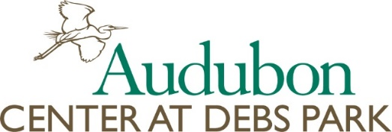

Individual Participant Scholarship Application
Name of Parent/Guardian:________________________________________________________________________
Address: ______________________________________________________________________________________
Phone(home): _______________________________Phone(cell):_________________________________________
Name of Child:____________________________________ Age:_________________ Gender: _________________
Does your child receive a free school lunch?__________________________________________________________
Name of program for which scholarship is being requested: _____________________________________________
Can you provide transportation for your child to the Audubon Center at Debs Park (ACDP)?____________________
Have you applied for (yes/no) or received (yes/no) a scholarship from ACDP? _______________________________
Total program costs for this participant: $475.00 Amount of scholarship funds you are requesting: _____________
If there is a shortfall between what our scholarship program can allocate and the total cost for the program, how will you make up for the difference?

How do you hope your student/child will benefit from a scholarship and participation in An Arroyo EDventure Summer Camp program?

Please provide the following information:
Gross monthly income: ______________________ Gross month expenses:_________________________
Do you own a home?
Please feel free to add any additional information you feel may help us make as informed a decision as possible.

Which week(s) of An Arroyo EDventure Summer Camp could your child attend?
⃝ Week 1 - July 9-13 ⃝ Week 3 - July 23-27

⃝ Week 2 - July 16-20 ⃝ Week 4 - July 20- Aug 3

Please note the following guidelines for applicants:
1. Consideration will be given to early applicants.
2. Scholarships will be awarded based on need.
3. Priority may be given to campers that have not previously received a scholarship. I certify that the information I have provided is true to the best of my knowledge.

Signature:____________________________________________Date:____________________________
Parent email:__________________________________________________________________________

For Office Use Only:
Date rec’d__________ Camp Registration Forms Received__________________

If you have any questions, please contact:
Lauren Hill, Volunteer Coordinator and Education Lead
323-221-2255 x14
lhill@audubon.org

